**Project Design Phase-I**

Solution Architecture

|  |  |
| --- | --- |
| Team Id | NM2023TMID04415 |
| Project Name | Block chain Technology For Electronic Health Records |

**Electronic Health Record (EHR):**

Elektronisk pasientjournal (EPJ) is the Norwegian Electronic Patient Record format that records health information of users and has been primarily used by health providers in Norway. An EPJ system stores EPJ files in databases and offers an interface for registering, searching and displaying information from the EPJ files, etc. Such databases are (partly) open to users and other providers with different specified permissions. Currently, this EPJ system, like the electronic health record (EHR) systems in many other countries, is fragmented across health providers and the entire system has yet to be integrated. The health records of a user are maintained in different health providers’ databases, causing that the providers can not have a comprehensive overview of all the records of a single user.

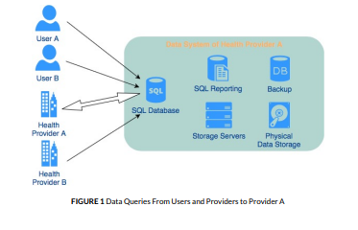

**Block chain:**

The concept of block chain technology was first introduced by Satoshi Nakamoto in the well-known paper on the Bitcoin 1 , and since then has drawn a lot of attention from both academic and industrial fields. In addition to Bitcoin and other financial applications, it has recently been applied to information and communication technology areas as well.

**Block chains for E-healthcare systems:**

The E-healthcare system is believed to be one of the fields where block chain has great potential due to its inherent characteristics, especially for the management of electronic health records. Significant research efforts have been made in this direction in the last few years. In 2016, Azaria et al. proposed a decentralized records management system, termed MedRec, which was built on the Ethereum platform and utilized Ethereum’s smart contracts to create an intelligent representation of existing medical records stored within individual nodes on the network 9 . Patients have control over their medical records across providers and treatments sites in this system.

**A BLOCKCHAIN-BASED ARCHITECTURE:**

**Overview:**

To alleviate health providers’ workload of adopting the block chain solution, we propose an architecture building on top of the existing providers’ databases. All accesses to the health records in these SQL server databases have to go through the block chain, which then keeps track of all logs of queries, such as select, insert and delete, etc. Ownerships and access rights of records are important metadata added to the chain in addition to the logs. In this way, the history of all accesses is stored on the block chain that provides a full view of all events that have happened to each record, and hence guarantees data integrity and prevents misuse of user records.

**Implementation of the Block chain Initialization:**

Suppose n healthcare providers (P) agree to join the block chain network to share their records. In general, they are assumed to agree on:

* The Summary Contract and the Record Relationship Contract;
* The calculation of significance and the incentive mechanism when a new block is added to the chain;
* Levels of frequency for updating the block chain (e.g., daily, emergency case);
* The processes of generating, verifying, and appending a new block.

**The Cycle of Block chain:**

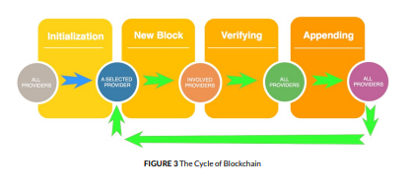

**Usage Scenarios:**

**A user reads his/her health record from a provider:**

A user wants to read his/her record from a provider’s database. He/she makes a query request to access the record. This query, together with a return value that is either the requested data or an access denied message, will be a log that is hashed and added to the RRC.

**A health provider reads records from another provider:**

A provider B wants to read a user’s record from provider A’s database. B makes a query request to provider A. This query together with a return value that is either the requested data or an access denied message, will be a log that is hashed and added to the RRC.

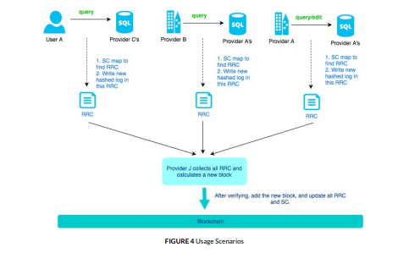

**The Incentive Value c:**

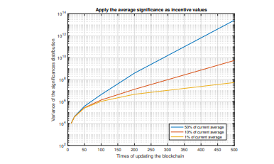

**The Selection of Block Creators:**

